1. Extracting flume tar file and updating the flume home. Also the Flume agent is done and the Consumer Key, Consumer Secret, Access Token and Access Token Secret are updated

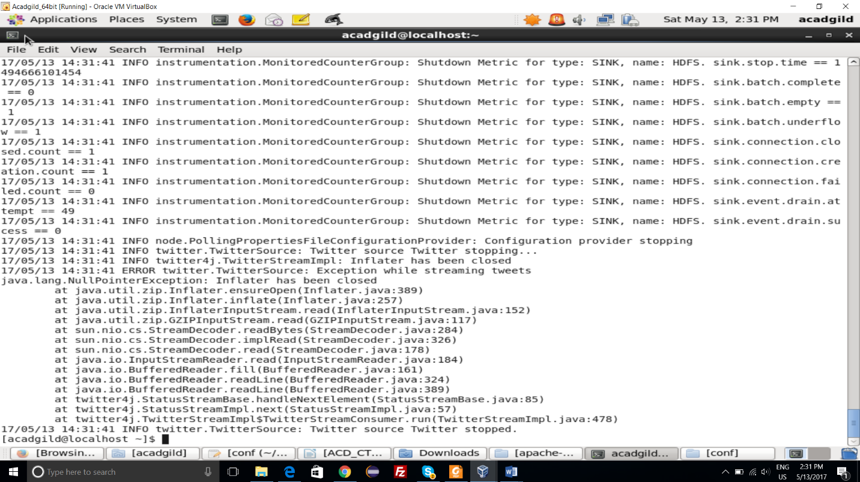

2) Flume Agent is running and starts fetching data from the Twitter in Live.

Command : flume-ng agent –n TwitterAgent -f /home/acadgild/Downloads/apache-flume-1.6.0-bin/conf/conf

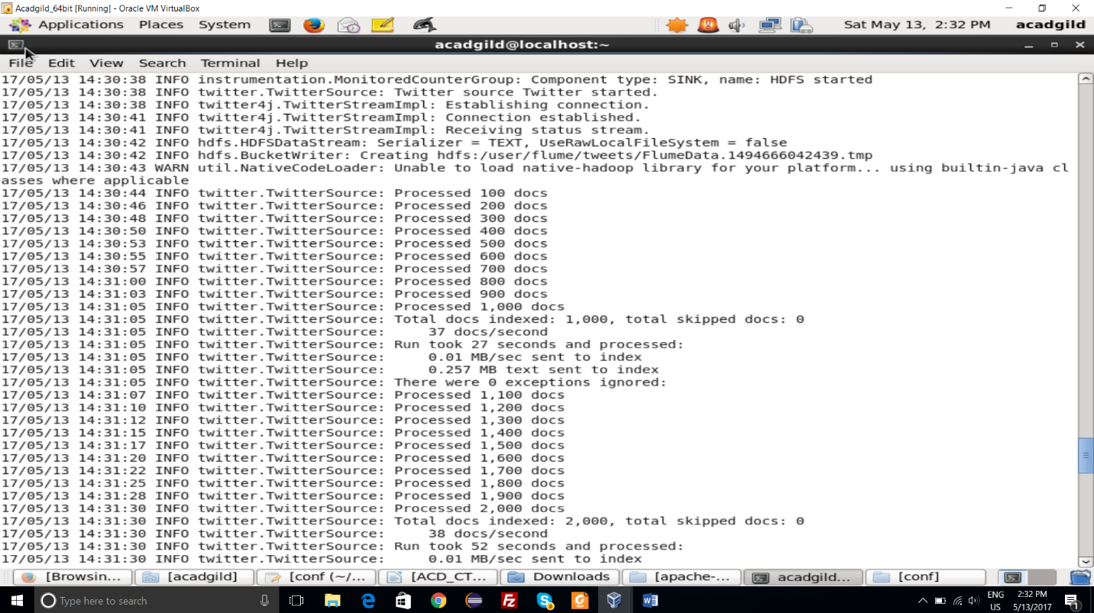

1. Live data of around 2200 documents were processed and the Result is as Follow

Command : hadoop fs –cat /user/flume/tweets/FlumeData.1494666042439

